Consider accessibility during user research.

**Accessibility** is the design of products, devices, services, or environments for people with disabilities. Designing for accessibility is about considering all users’ journeys, keeping their permanent, temporary, or situational disabilities in mind. By researching how people with disabilities interact with products like yours, you can better understand how to design for them. It’s not possible to accurately guess all the ways that a user might experience your product, which is one reason why including people with disabilities in your research is so important.

Here are a few considerations for you to take into account when conducting research during the empathize phase of the design process.

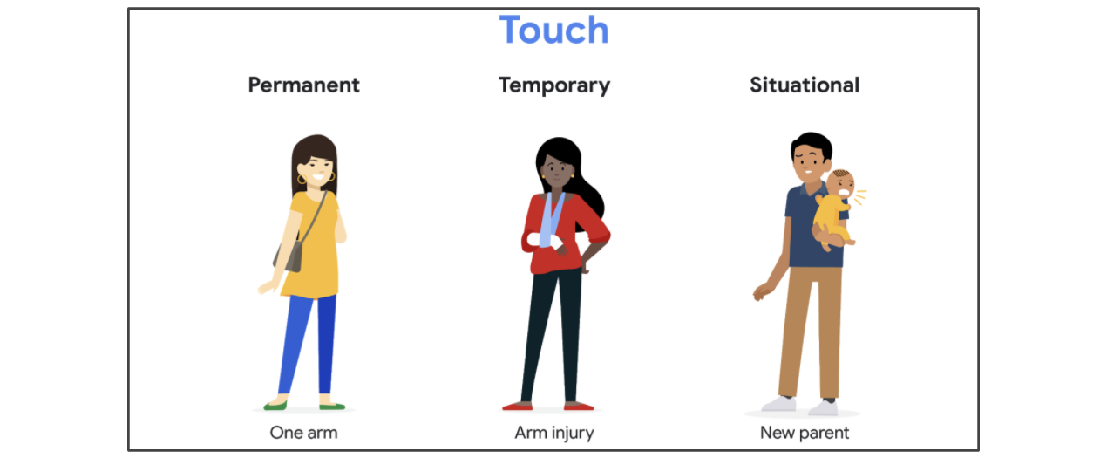ranging from Permanent (one arm), Temporary (arm injury), and Situational (new parent)

**Touch:**How would you design for users who have use of one arm, either permanently, temporarily, or situationally?

* Decide where to place buttons within your design based on several different hand sizes.
* Create a feature that allows double taps to avoid accidental icon clicks.
* Enable the one-handed keyboard feature and general keyboard compatibility.
* Allow button customization for easy access to information that the user finds most important.

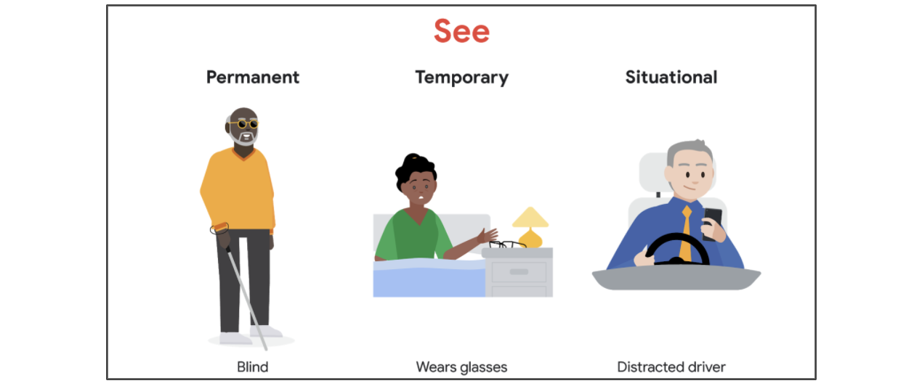Ranging from Permanent (blind), Temporary (wears glasses), to Situational (distracted driver)

**See:**How would you design for users who have limited vision, either permanently, temporarily, or situationally?

* Use a larger font to create a reader-friendly design of the app.
* Ensure the app and the images have alternate text that can be read by a screen reader.
* Detect whether the user is operating a motor vehicle.
* Design the app with high contrast colors.
* Don’t rely on text color to explain navigation or next steps. For example, don’t use red text alone as an indicator of a warning. Instead, your design should include explicit instructions.

**Customizable text**

There are some additional web accessibility tools that individuals with dyslexia or other visual processing disabilities may benefit from. One of these ways is **customizable text**, a feature that allows users to change how text is displayed in order to read the text more easily.  Text customization involves changing everything from the color or font to the size or even the spacing of the text. For example, some fonts may be easier for users to read , so customizing fonts could be a great help. Therefore, customizable text allows more options than simply magnifying the text or zooming in, making the content more adaptable yet maintaining the functionality.

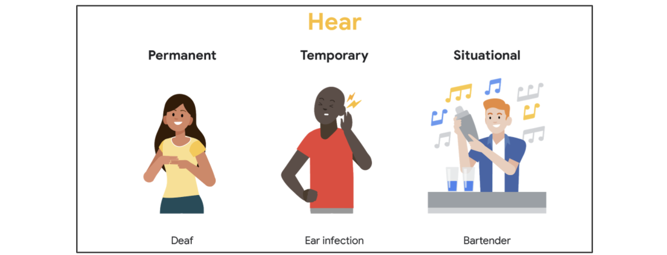Ranging from permanent (deaf), temporary (ear infection) to situational (bartender)

**Hear:**How would you design for users who have limited hearing, either permanently, temporarily, or situationally?

* Don’t rely solely on sounds to provide app updates, like a new message notification. Instead, enable haptics, which are vibrations that engage a user’s sense of touch, and notification lights.
* Apply closed captioning to all videos.
* Provide a text messaging system within the app to allow users to communicate through writing.

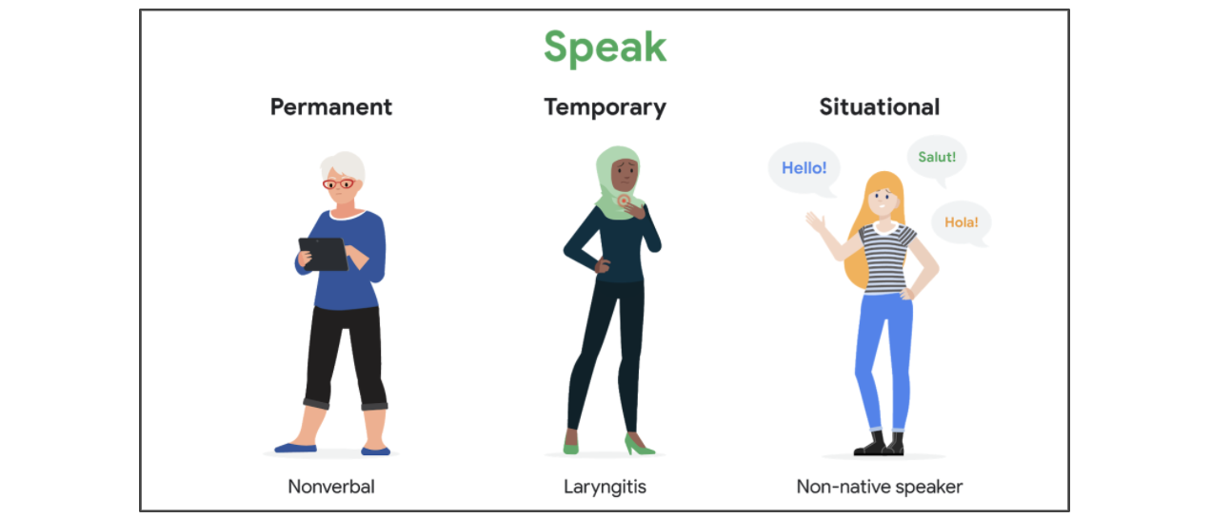Ranging from permanent (nonverbal), temporary (laryngitis), to situational (non-native speaker)

**Speak:**How would you design for users who cannot speak, either permanently, temporarily, or situationally?

* Provide written intros, descriptions, and instructions for users, in addition to video-based content.
* Provide Real-Time Texting during phone calls with users or with app support.
* Arrange alternatives for automated systems that rely on speech recognition.
* Provide an in-app messaging system that allows the use of emojis and image uploads.

This list is just a small fraction of the considerations you should take into account when designing for users with disabilities. The best way to learn about how to improve your designs is to conduct research and get feedback from people with disabilities directly.

**Assistive technologies**

Creating a product design that takes every range of ability into account can be incredibly difficult. Thankfully, there are services and apps designed to help bridge the gap. For example, one service that’s recently been added by phone providers is [Real-Time Texting](https://support.google.com/accessibility/android/answer/9042284?hl=en), which lets users text during a phone call to improve communication.

Another feature that helps people with disabilities is alternative text. People who have low vision or are blind often rely on screen readers to read the content on their screens aloud. But, if your informational icons don’t have labels or alternative text, the screen reader can’t describe the functionality of that button to the user. Not every image or icon is informational, so only include descriptions when necessary.

Researching and learning about assistive technology will help you better understand the impact these technologies have. Here are a few links to help you get started:

* Discussing the value of disability technology: [Disability Technology](https://www.youtube.com/watch?v=eFkhFxJZvho) from TEDx Talks on YouTube
* How accessibility in technology changes lives: [How the Blind Use Technology to See The World](https://www.youtube.com/watch?v=0EQOZRIA-nA) from TEDx Talks on YouTube
* An explanatory guide for phone accessibility: [Smartphone accessibility: a comprehensive guide](https://www.uswitch.com/mobiles/guides/smartphone-accessibility/) from Uswitch
* Google’s [accessibility information hub homepage](https://www.google.com/accessibility/)

**Putting inclusive design into practice**

To put inclusive design into practice, it’s important to immerse yourself in the assistive technology that people with disabilities might use and to have conversations with them about their experiences. The best way to design empathetically for the world around you is to engage with your users and ask them questions about the way your designs could help them succeed.

To learn more about inclusive design, here are some additional resources to get you started:

* Describing ways to design products inclusively: [Inclusive Design: 12 Ways to Design for Everyone](https://www.shopify.com/partners/blog/inclusive-design) from Shopify
* Google’s accessible approach to inclusive design: [An Accessible Process for inclusive Design](https://www.youtube.com/watch?v=TAzkrXTGEOM&feature=emb_title) from Google I/O
* Breaking down important inclusive design principles: [6 Principles for Inclusive Design](https://uxplanet.org/6-principles-for-inclusive-design-3e9867f7f63e) from UX Planet